Game Design Document

Fill up the following document

1. Write the title of your project.

My True Identity

1. What is the goal of the game?

The goal is to collect all the three diamonds to find Ivy’s true identity.

1. Write a brief story of your game.

Ivy was born with the magical power of transformation. She

eventually gets curious about her true identity as it is not normal.

So she sets on an adventure to find her true identity .

1. Which are the playing characters of this game?

* Playing characters are the ones who respond to the user based on the input from the user.
* Cars, monkeys, dinos, wizards, etc., are the playing characters in the game.

|  |  |  |
| --- | --- | --- |
| Number | Character Name | What can this character do? |
| 1 | Ivy | The character can collect coins and diamond. |
| 2 | Ivy’s transformation in water | In water Ivy changes into a fish but it can collect coins and diamond. |
| 3 | Ivy’s transformation in air | In air Ivy changes into a bird but it can collect coins and diamond. |
| 4 |  |  |
| 5 |  |  |
| 6 |  |  |
| 7 |  |  |
| 8 |  |  |

1. Which are the Non-Playing Characters of this game?

* Non-Playing characters are the ones that don't have an action or behavior when the user interacts with the game.
* Hurdles, stones, bananas, coins, etc., are non-playing characters in the game.

|  |  |  |
| --- | --- | --- |
| Number | Character Name | What can this character do? |
| 1 | Coin | It adds up to the score. |
| 2 | Fire | It can reduce the score by half. |
| 3 | Shark | It can reduce the score. |
| 4 | Airplane | It can reduce the score. |
| 5 | Diamond | It can help the PC to enter the next stage. |
| 6 |  |  |
| 7 |  |  |
| 8 |  |  |

Draw your imagination of this game. What does this game look like?

* Draw the game either on your computer or on paper.
* Add images of the game scenes to show each of the playing and non-playing characters at least once.

Coin and Diamond

 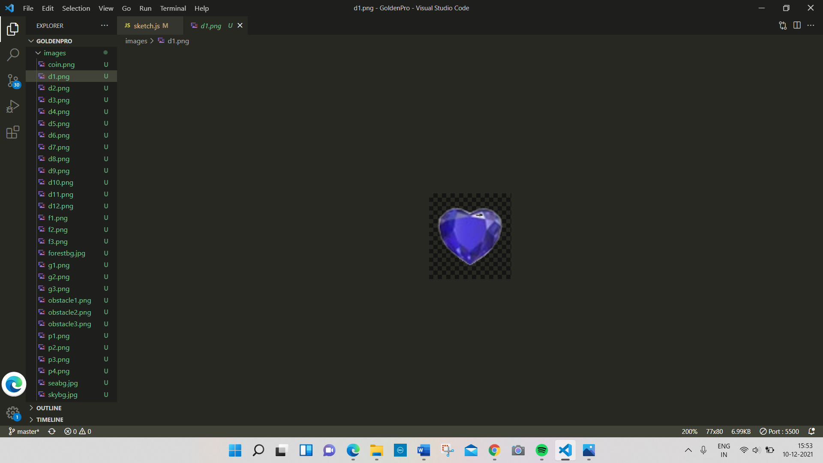

Playing Characters:

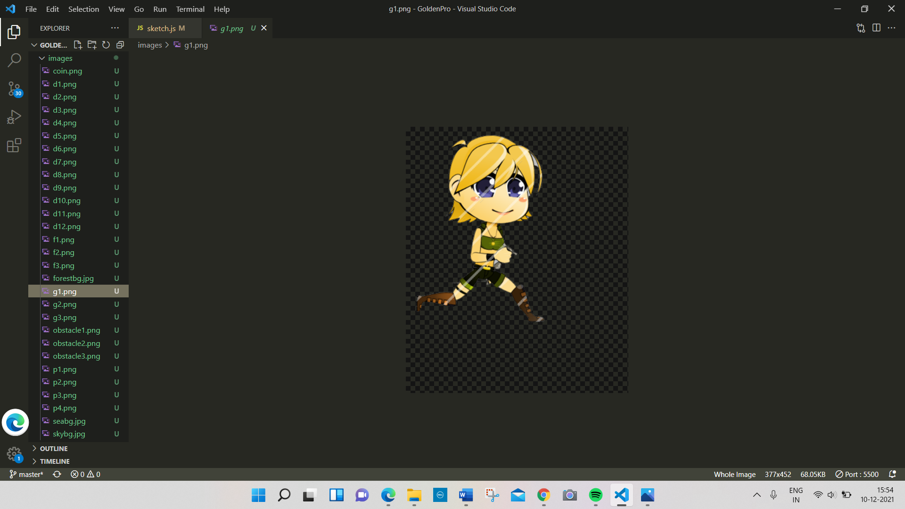

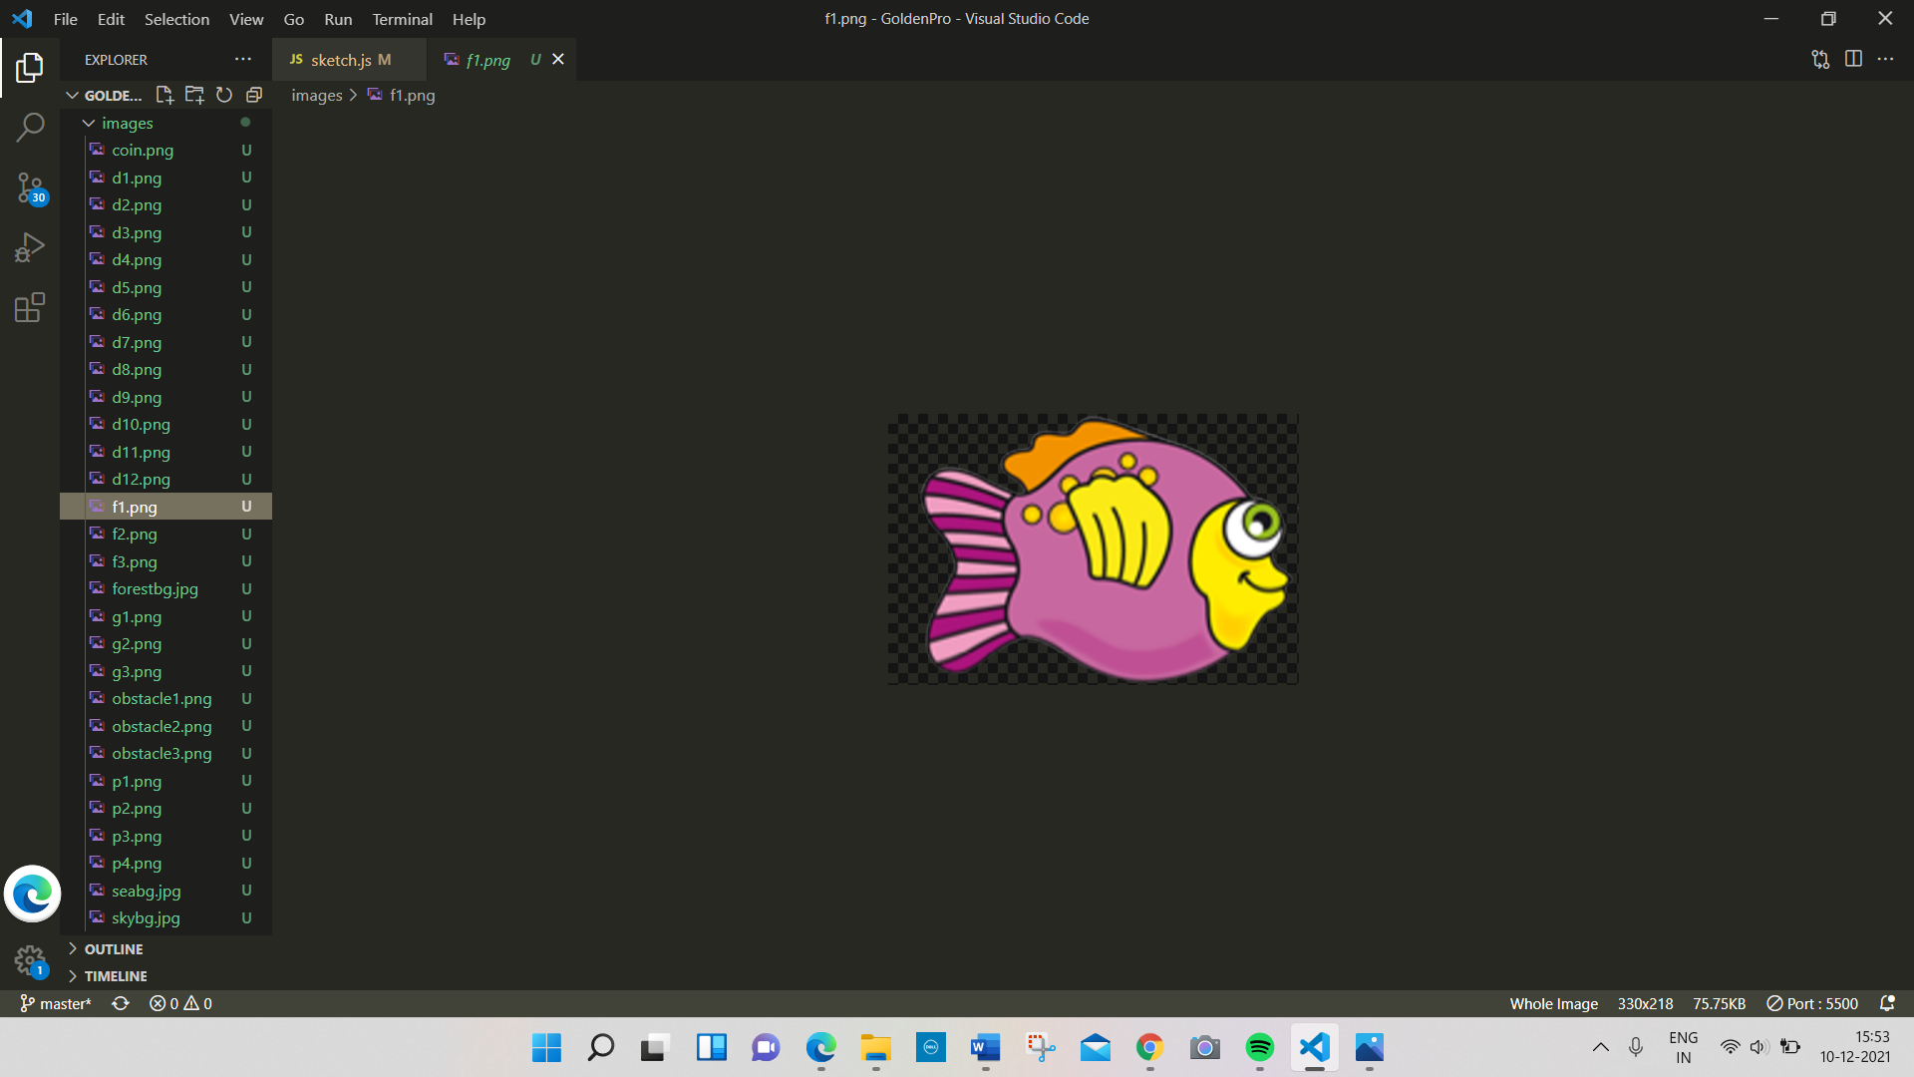 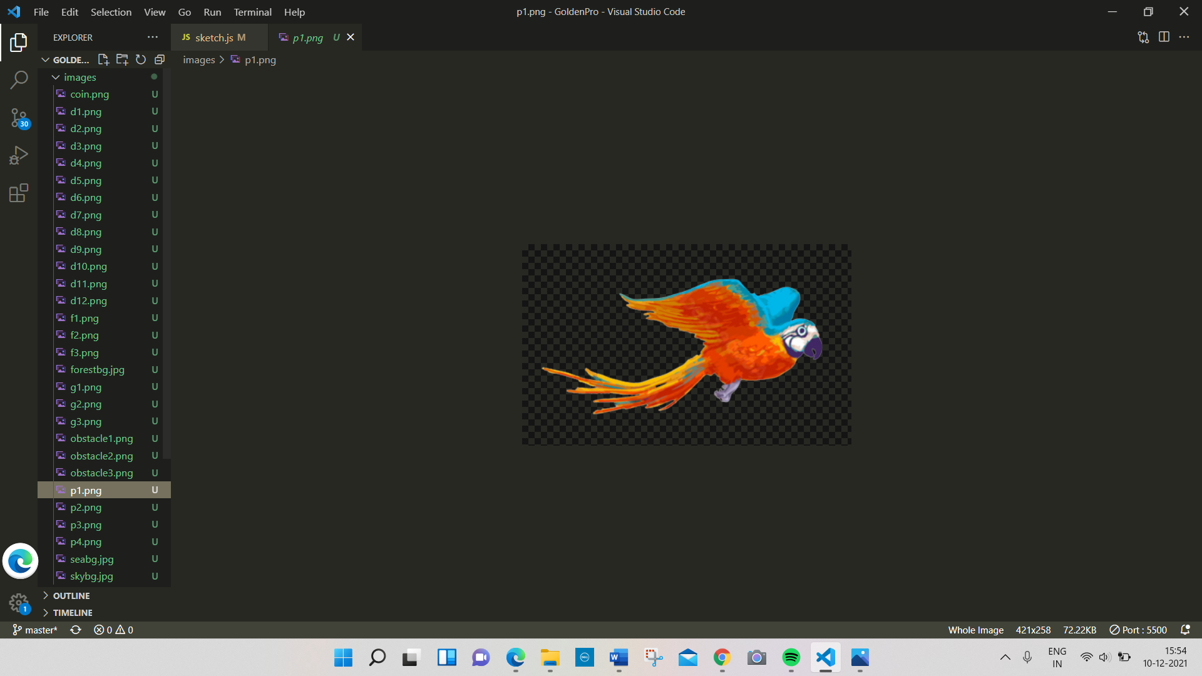

Obstacles:

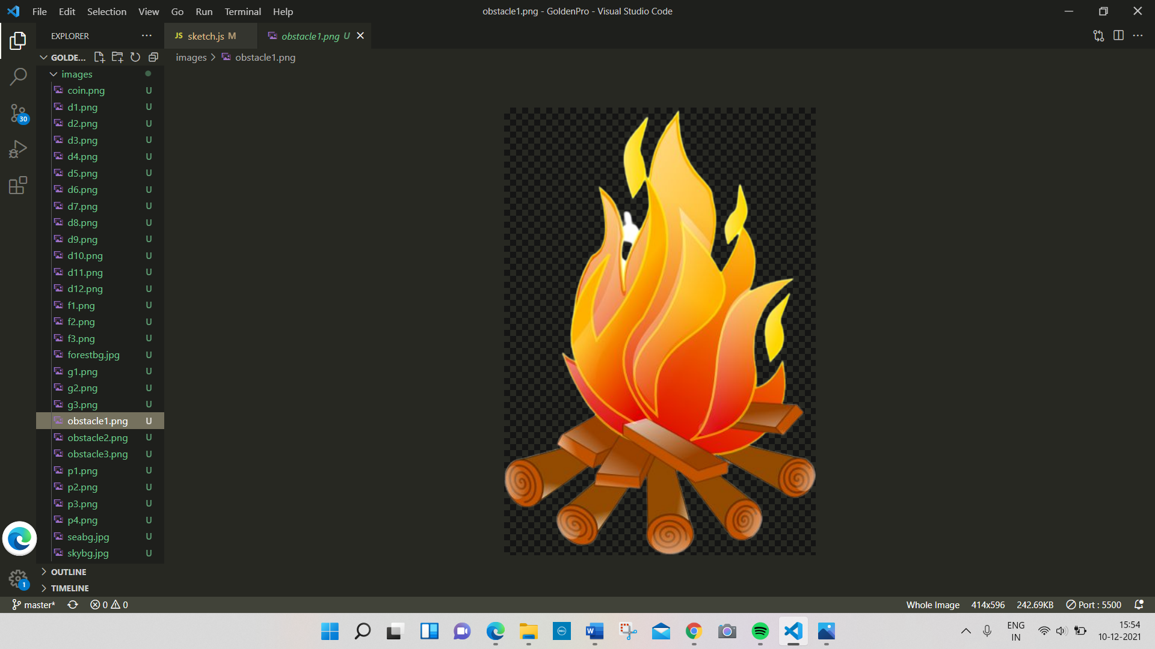

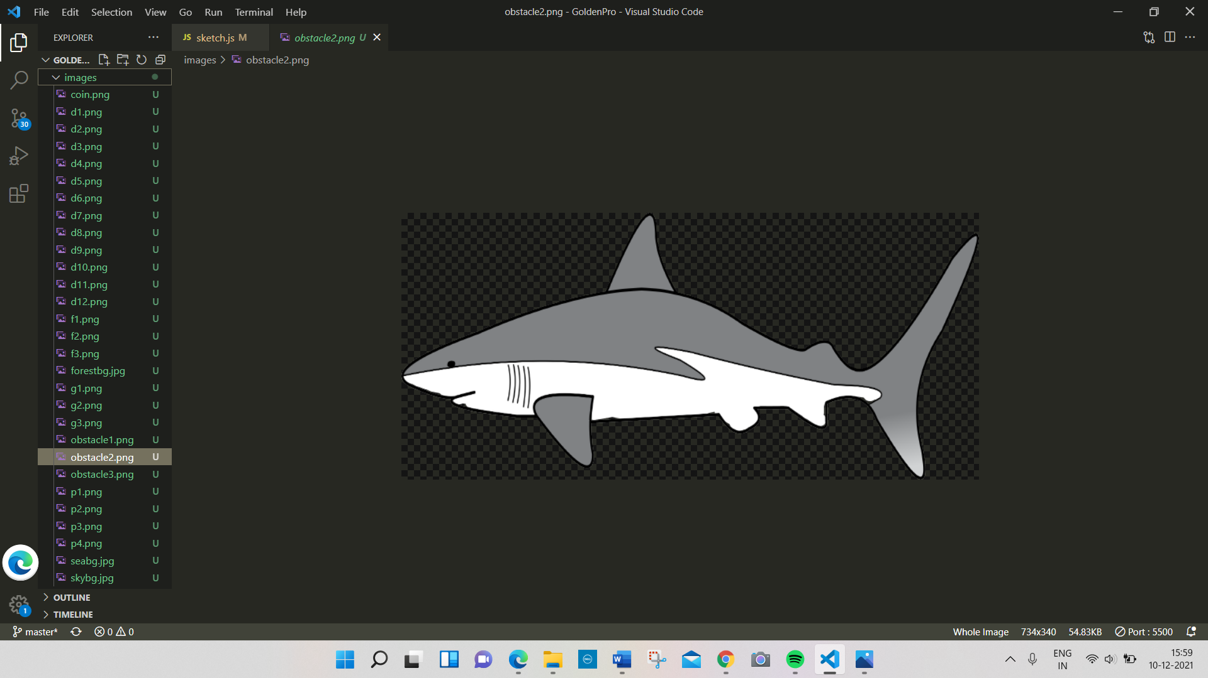 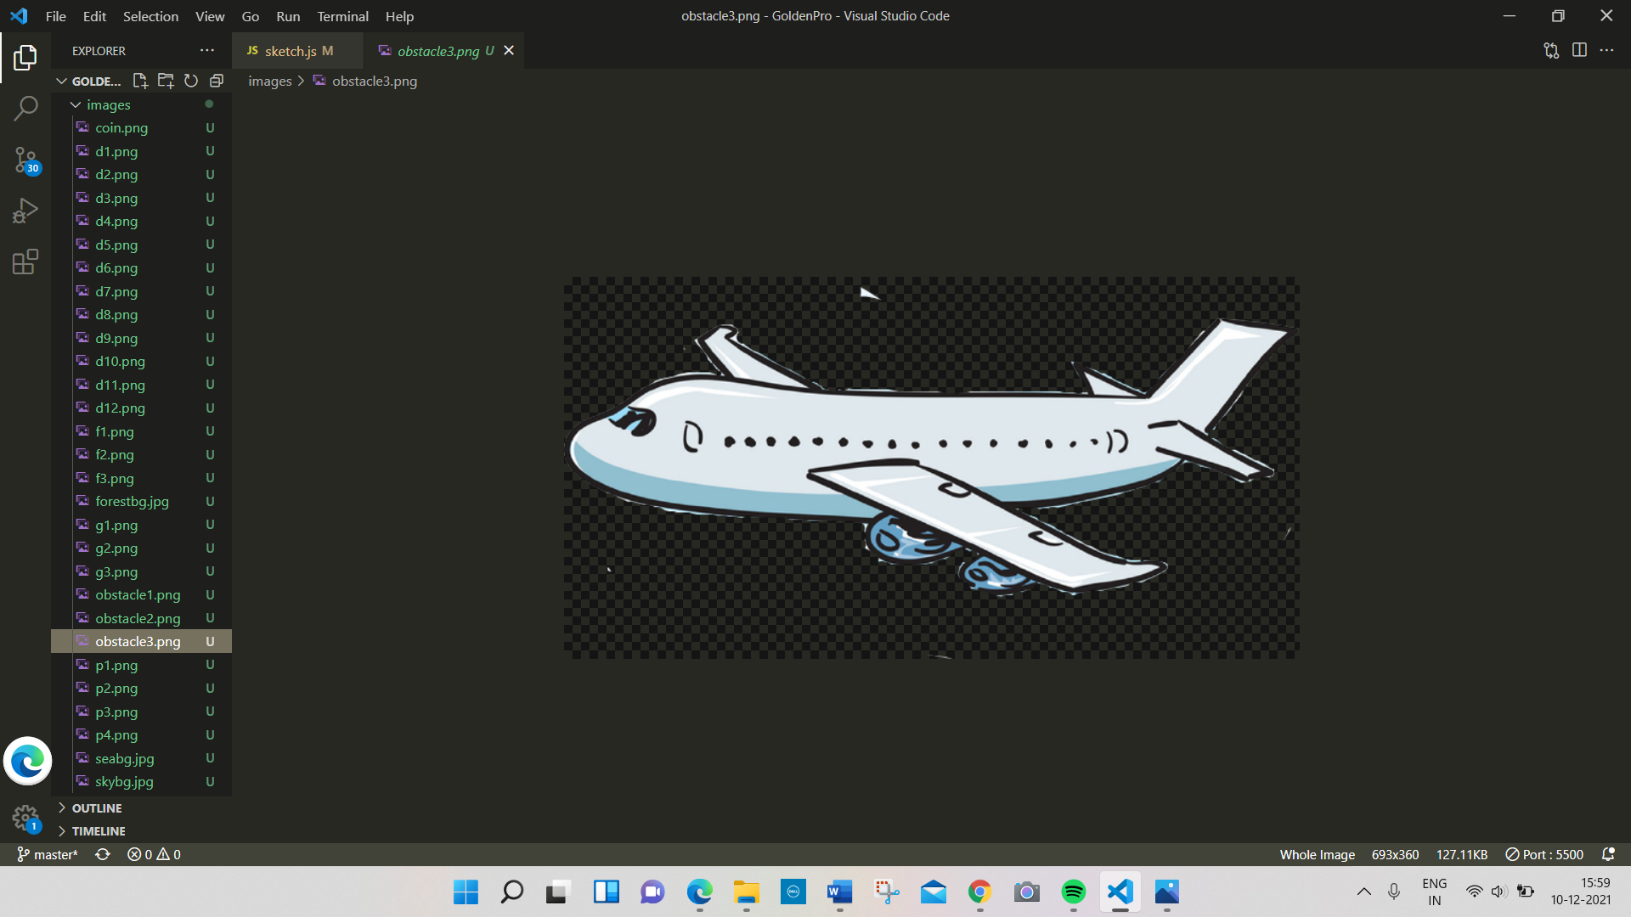

Stages:

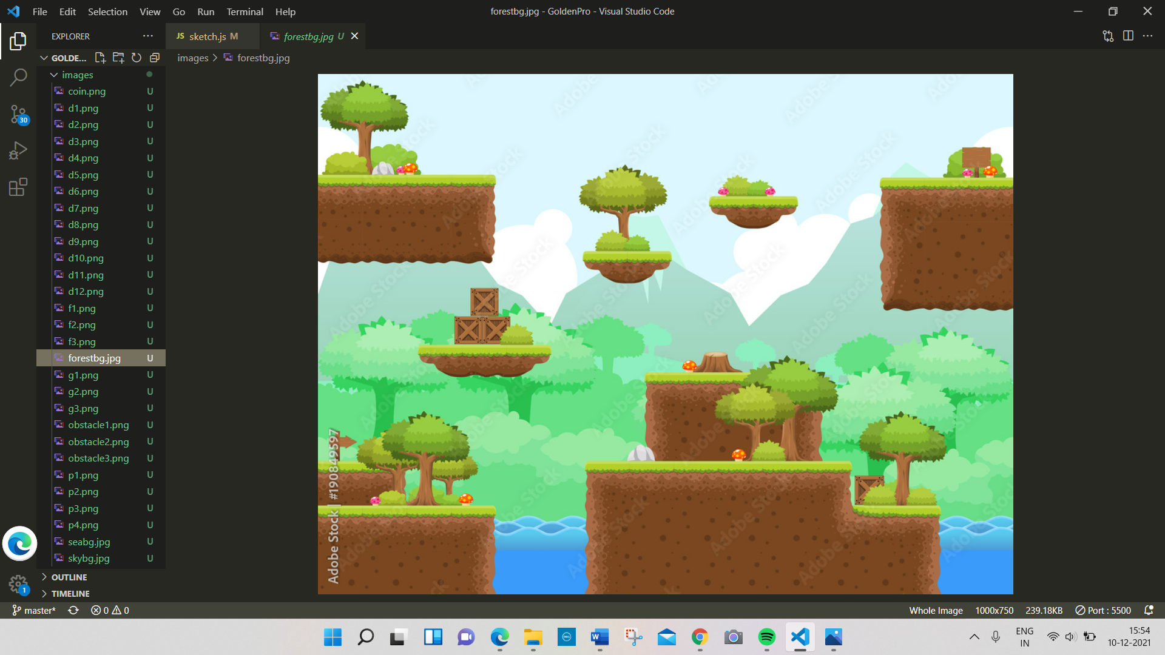 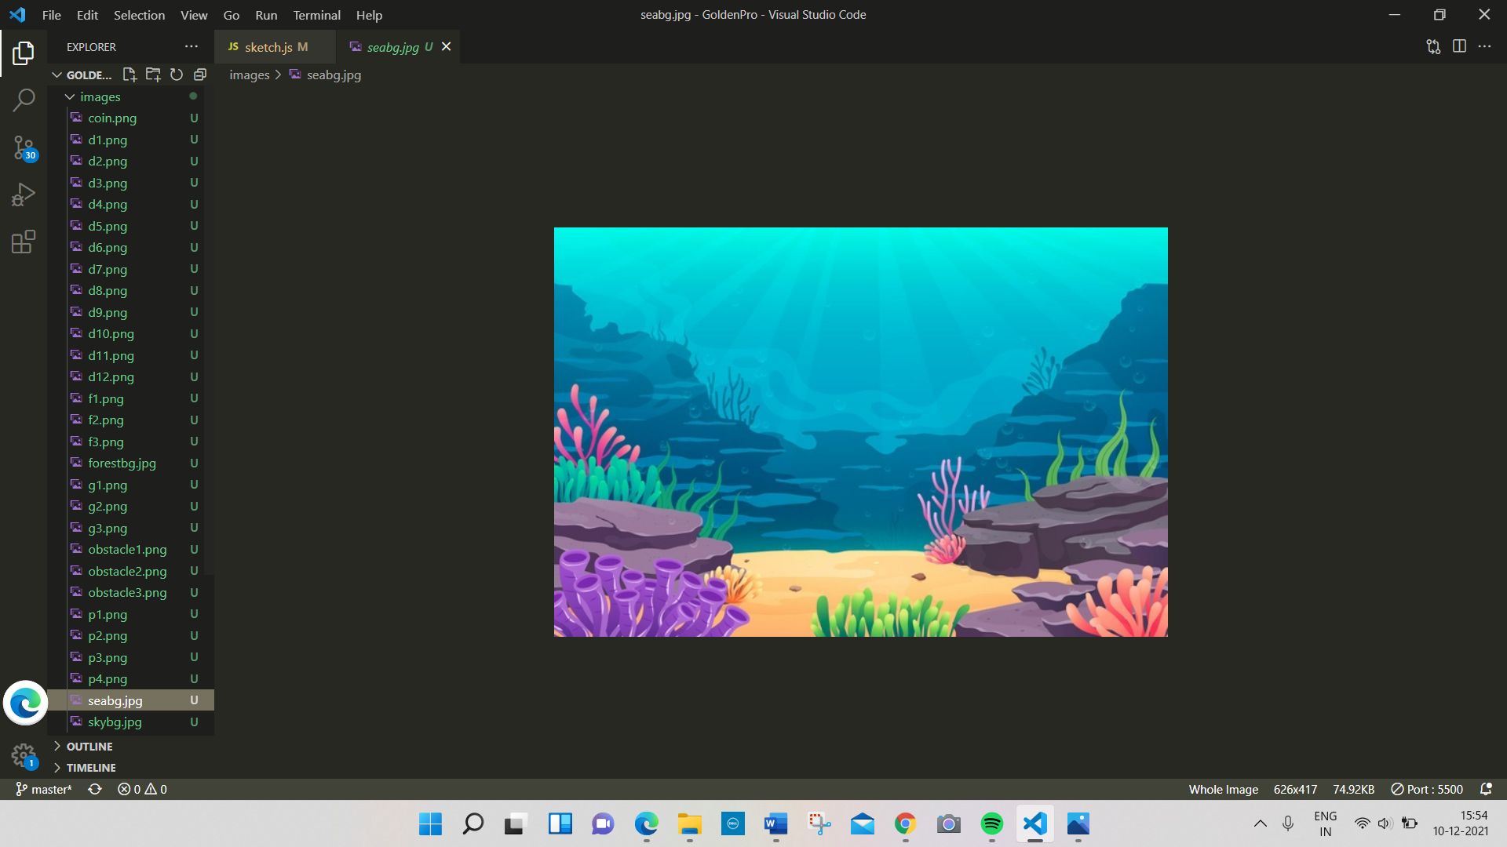 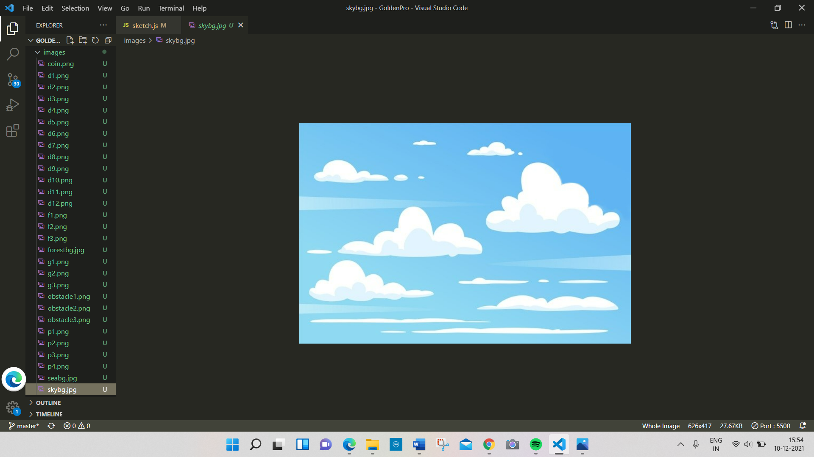

How do you plan to make your game engaging?

I plan to make 3 stages in the game. The player can pass to the next stage

only if he/she gets the essential score which is only possible when the

player collects the diamond. If the player touches and obstacle, the score

will be reduced. In the end the true identity of the girl is

revealed.